Archdiocese of Baltimore Incident Report Entry Guide
- To report an injury, you will use this link that will take you to the AOB First Report of Injury Form:
AOB Claim Entry Form
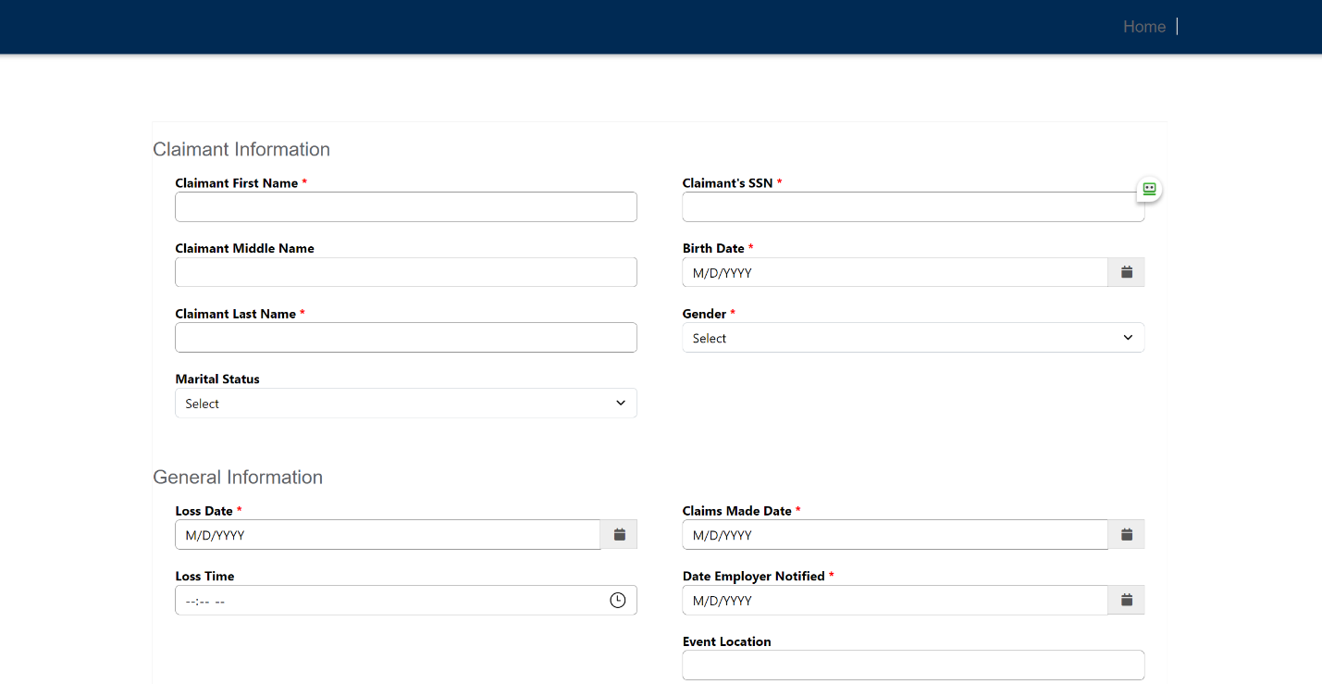
- You will be directed to this page, and you can begin to enter claims information

- On the reporting page, complete all known fields on the Incident Report. Required fields are noted with a red * asterisk. Reminder: It is best practice to enter as much information as possible, even if it is not required.

- Further details for several of the required fields:
  - Event Location – is the location where the injury occurred. i.e. “School lunchroom” or “Parish Hall” or enter the location address.
  - Reporting Location – is the employer. If you are at a location where there has been a merger or Seek the City transition, please select the seated parish as the reporting location.
  - Accident Description – Please include details on the incident but please refrain from using the injured employees name when describing the incident. You could instead refer to them as the “IE” for “Injured Employee”.
  - Incident Information – see below for more information regarding the Safeguards questions.

  - OSHA Recordable – Please visit this website for determining the correct setting for the incident. https://www.osha.gov/report.html
This field defaults to NO. Once the claim is assigned, the SISCO adjuster will assist when needed to determine if the incident is OSHA recordable. Important Note: Contact riskmanagement@archbalt.org when the injury involves a fatality, an in-patient hospitalization, amputation or loss of an eye.
  - The safeguards fields are a standard field on the workers compensation form, but are not required. If you choose not to answer, you can leave them to default to no.
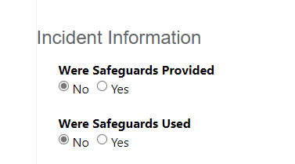

- Reference Guide for icons displayed on claim entry screen

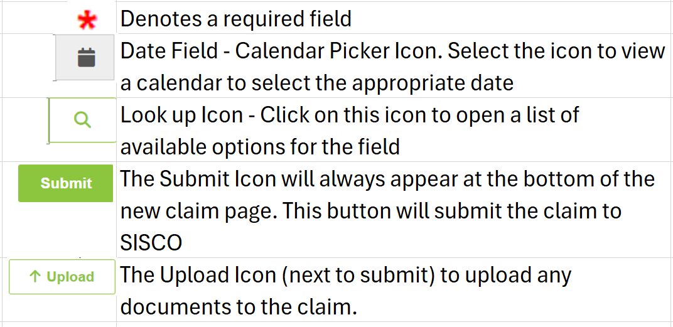

- To upload any documents, click on the upload button at the bottom of the
screen and select the desired documents to attach to the claim
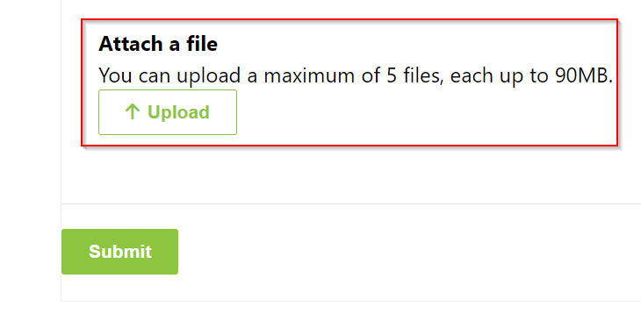

- Once all appropriate fields have been completed, click the Submit button at the bottom of the screen
- Once the claim is submitted, a SISCO Supervisor will assign the claim to the appropriate adjuster for review.

For questions regarding the completion of the Incident Report, please contact Archdiocese of Baltimore Human Resources.

For technical questions or issues with this process, please email SISCO Support sisco.support@rcmd.com.

