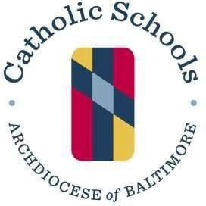
320 Cathedral Street
Baltimore, MD 21201
P: 410-547-5515
F: 410-547-5566

May 17, 2024

Dear School Presidents and Principals,

The 2024-2025 school year will mark the 15th year that the Department of Catholic Schools, in conjunction with the Office of Risk Management, have promoted the general-use epinephrine pen program. This program is designed to ensure awareness of critical allergic reactions which can result in life-threatening anaphylaxis and to have available a supply of epinephrine pens.

During the first 13 years of the deployment of the program, there were a total of ten pens deployed in response to emergency circumstances. During this current school year, there have been a total of six such deployments. Having this program in place at each school be a priority.

For the FY 24/25 school year, the Office of Risk Management is releasing the plan documents currently, which is earlier than previously, in order that your school can complete the necessary program document and ensure you have time to order needed supplies to support the program. As a reminder, the program also continues to have available the needed medical direction if your school does not have an individual available in your community qualified to provide the required medical direction. Rescue One Training for Life, Inc., is continuing to offer the medical direction for a fee of $50.00.

The documentation required to participate in this program will be available beginning May 15, 2024 at https://www.archbalt.org/office-of-risk-management/epinephrine-program/. Any questions regarding this program or the plan documents should be directed to Tom Alban at talban@archbalt.org, Diana Appel at diana.appel@archbalt.org, or Kathleen Russo-Garcia at Kathleen.russogarcia@archbalt.org.

We hope each school will enroll to participate in this critical program.

All the best,

Gregory A. Farno
Chancellor of Education

